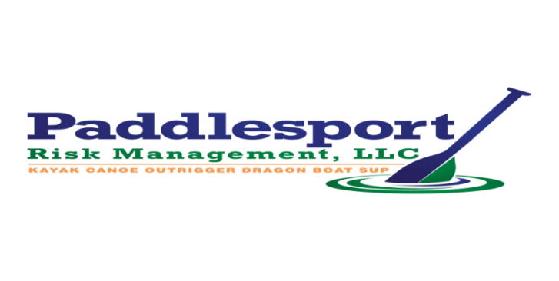

AMATEUR ATHLETIC WAIVER AND RELEASE OF LIABILITY
READ BEFORE SIGNING.
PADDLER WAIVER 2018 - 2019
NAME OF CLUB: Miami Dragon Slayers COVERAGE TERM: 02/11/2018 - 02/11/2019

In consideration of being allowed to participate in any way in this sports activity, related events and activities, the undersigned acknowledges, appreciates, and agrees that: The risk of injury from the activities involved in this sport is significant, including the potential for permanent paralysis and death; and while particular rules, equipment, and personal discipline may reduce this risk, the risk of serious injury does exist; and, I KNOWINGLY AND FREELY ASSUME ALL SUCH RISKS, both known and unknown, EVEN IF ARISING FROM THE NEGLIGENCE OF THE RELEASEES or others and assume full responsibility for my participation; and, I willingly agree to comply with the stated and customary terms and conditions for participation. If, however, I observe any unusual or significant hazard during my presence or participation, I will remove myself from participation and bring such hazard to the attention of the nearest official immediately; and, I, for myself and on behalf of my heirs, assigns, personal representatives and next of kin, HEREBY RELEASE AND HOLD HARMLESS the Paddlesport Risk Management, LLC, Miami Dragon Slayers, Miami Rowing & Watersports, City of Miami, Treasure Coast Dragon Boats, their officers & directors, officials, agents, and/or employees, other participants, sponsoring agencies, sponsors, advertisers, volunteers, coaches, steerers, and, if applicable, owners and lessors of premises used to conduct the event (“RELEASEES”), WITH RESPECT TO ANY AND ALL INJURY, DISABILITY, DEATH, or loss or damage to person or property, WHETHER ARISING FROM THE NEGLIGENCE OF THE RELEASEES OR OTHERWISE. I also acknowledge that photographs and video may be taken of me in my participation in, and attendance at this event, and hereby freely agree to allow without restriction all uses of such photos and videos in the reporting of this race, and/or in the promotion of this event, its location, other sporting events, sport in general, and/or related purposes. I HAVE READ THIS RELEASE OF LIABILITY AND ASSUMPTION OF RISK AGREEMENT, FULLY UNDERSTAND ITS TERMS, UNDERSTAND THAT I HAVE GIVEN UP SUBSTANTIAL RIGHTS BY SIGNING IT, AND SIGN IT FREELY AND VOLUNTARILY WITHOUT ANY INDUCEMENT.

Signature: ___________________________________________________________________________
Print Name: ___________________________________________________________________________

Address: ___________________________________________________________________________

City: ________________________________________ State: ___________

Phone: ________________________________________ Date: ______________________

