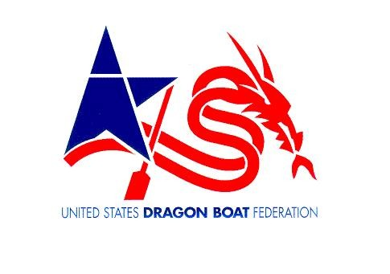
AMATEUR ATHLETIC WAIVER AND RELEASE OF LIABILITY

READ BEFORE SIGNING

CLUB NAME: Miami Dragon Slayers DBRT TERM: Current Year

In consideration of being allowed to participate in any way in the UNITED STATES DRAGON BOAT FEDERATION, (USDBF) and its affiliates athletic sports program, related events and activities, the undersigned acknowledges, appreciates, and agrees that: The risk of injury from the activities involved in this program is significant, including the potential for permanent paralysis and death, and while particular rules, equipment, and personal discipline may reduce this risk, the risk of serious injury does exist; and, I KNOWINGLY AND FREELY ASSUME ALL SUCH RISKS, both known and unknown, EVEN IF ARISING FROM THE NEGLIGENCE OF THE RELEASEES or other and assume full responsibility for my participation; and, I willingly agree to comply with the stated and customary terms and conditions for participation. If, however, I observe any unusual significant hazard during my presence or participation, I will remove myself from participation and bring such to the attention of the nearest official immediately; and, I, for myself and on behalf of my heirs, assigns, personal representatives and next of kin, HEREBY RELEASE AND HOLD HARMLESS the UNITED STATES DRAGON BOAT FEDERATION; Miami Dragon Slayers, Treasure Coast Dragon Boats, LLC; the City of Miami; and the Miami Rowing and Watersports Club; their respective officers, directors, coaches, steerers, volunteers, officials, agents, and/or employees, other participants, municipalities, sponsoring agencies, sponsors, advertisers, and, if applicable, owners and lessors of premises used to conduct club & activities (“RELEASEES”), WITH RESPECT TO ANY AND ALL INJURY, DISABILITY, DEATH, or loss or damage to person or property, WHETHER ARISING FROM THE NEGLIGENCE OF THE RELEASEES OR OTHERWISE.

I am also aware that photographs taken during club activities may be posted to the club website, or social networking site and may be used for publicity purposes only by the Club. I understand that I can paddle with the above club 2 times as a guest after which I must become a regular member to be covered under the Club liability coverage.

I HAVE READ THIS RELEASE OF LIABILITY AND ASSUMPTION OF RISK AGREEMENT, FULLY UNDERSTAND ITS TERMS, UNDERSTAND THAT I HAVE GIVEN UP SUBSTANTIAL RIGHTS BY SIGNING IT, AND SIGN IT FREELY AND VOLUNTARILY WITHOUT ANY INDUCEMENT.

___________________________________________ ____________________________________________
Name – Please Print Signature

_________________,20____
Date

___________________________________________________________________________ ________
Address Age

________________________________________ FL _______________
City State Zip

